Answers Free Response Unit 5 Progress Check

A
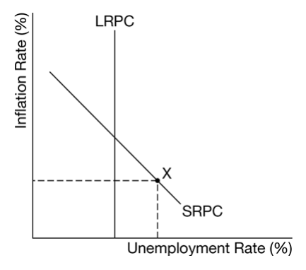

B
Expected inflation rate is greater than the actual inflation rate.

C
No, borrowers on fixed-rate loans will not benefit from the expected inflation rate being higher than the actual inflation rate because they will pay a higher real interest rate.

D
government budget will move into deficit and explains that automatic stabilizers such as transfer payments and progressive income-taxes will increase government spending and decrease government revenues

e
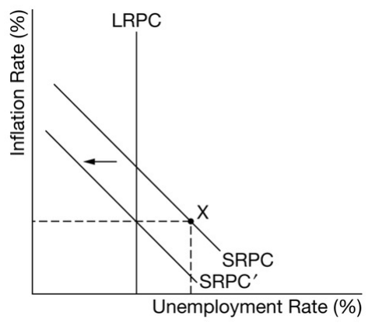

F
the national debt will increase.

G
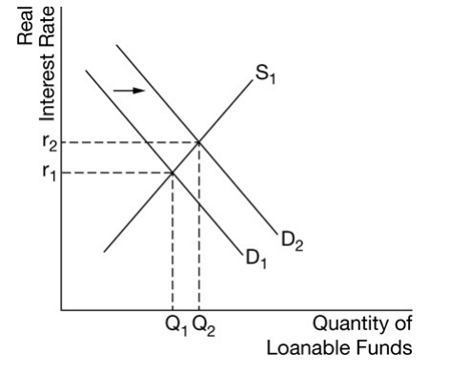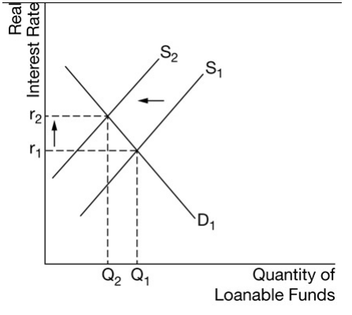

H
the country’s economic growth will slow in the long run and explains that an increase in real interest rates will increase the cost of borrowing, which decreases investment spending on plant and equipment and reduces capital formation

